NET ACTIVITY:  KEN: MONDAY 3.972.5 0030Z  KDN: TUESDAY 3.587 0130Z  KYN CW: DAILY 3.537 0200Z  STATEWIDE DMR: "KY STATEWIDE 0100Z - Thursday Evening "  ----------------------------------------  SM: w4nho@arrl.net  SEC: sec@kyham.net  STM: kc4bqk@arrl.net  ACC: n4ver.ky@gmail.com  TS: n9ky@arrl.net  OOC: k4lrx@arrl.net  PIO: w0qi@icloud.com  KYHAM: admin@kyham.net | KENTUCKY NEWS  KENTUCKY SECTION MANAGER  STEVE MORGAN W4NHO  OWENSBORO KY 42301  HAPPENING OF THE MONTH  February 2018 | 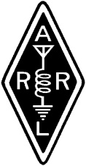

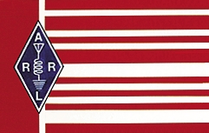
WHY ARE WE HERE?
Lets review the mission state of ARRL
ARRL's Vision Statement
As the national association for Amateur Radio in the United States, ARRL:
- Supports the awareness and growth of Amateur Radio worldwide;
- Advocates for meaningful access to radio spectrum;
- Strives for every member to get involved, get active, and get on the air;
- Encourages radio experimentation and, through its members, advances radio technology and education; and
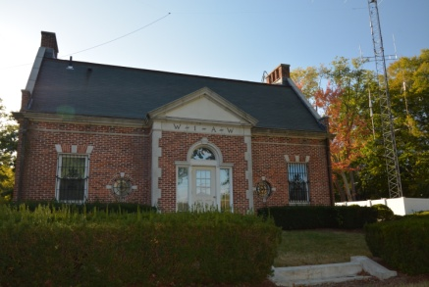
- Organizes and trains volunteers to serve their communities by providing public service and emergency communications.
Recently, ARRL Board of Directors convened January 19-20 in Windsor, CT for their bi-annual meeting. Much has been said and written about what took place during the 2 day meeting. It makes me proud to be a life member of the League and how the board listened to the membership. Without the League’s involvement with amateur radio for over 100 years – would be where we are today? There was a lot of correspondence to our perspective Directors in regards to different opinions. I was involved in the letter writing myself to Director Williams and President Roderick. I am also glad to see many of our members in Kentucky were also involved in letting their opinions known. In my opinion, the membership gave clear direction on their desires in the direction they would like to go. The board listened and decided to pause and review items under consideration especially in proposed amendments to our bylaws.
If you have the opportunity, give your regards to Director Williams for the board’s decision. Also, Director Williams was placed on the executive committee again for another term by their fellow board members. Director Williams and Vice Director Delaney normally attend the upcoming Cave City Hamfest on March 3rd. I hope many of you will stop by the League table and attend the League forum.
The League provides excellent publications for the newcomer and the old timer and all in between. We have all spent hours listening to code practice run from W1AW, learning CW when code was a requirement. W1AW continues to serve as a beacon of light for the latest bulletins when the internet is not available. Their work in the international world of amateur radio is so important in what they have done on the different WARC meetings. They continue to provide a world presence in regards to our radio spectrum in helping us earn additional spectrum allowance and guard what we have.
I am encouraged by the work of our affiliated clubs in the work that you do in providing classes for the newcomer in regards to Techs and other licenses such as the General. Elsewhere in the newsletter there will be a section for new amateurs coming into our great hobby and those that have either joined the League or renewed their membership with the League.
How often do we even look at the mission statement of the League. At times that have recently passed, we should pause and review the League’s purpose. Furthermore, glance the amateur’s code written by Paul Segal W9EEA in 1928. An amateur is “considerate, loyal, progressive, friendly, balanced, and patriotic”. Would our air wave sound better to the listener, if we all wore this code on our sleeve.
In conclusion, my comments cannot go silent without recognizing the outstanding work that is going on behind the scene by Kenny Garrett N4KLG KY SEC, Roman Rusinek KE6YCW, KY KYHAM administrator and numerous others out their like Jack Hedges KY4TPR, Jim Rayburn KC4BQK and Ron Goodpaster AG4TY in their work in reworking KYARES webpage kyares.net and the ARES Facebook page KY ARES DISCUSSION GROUP . Shortly ARES leadership and members will receive slightly new procedures on sending in your monthly reports. New appointments are in the work and we are grateful for several members stepping up to the leadership plate. Mother nature cannot keep a lid on our KEN frequency of 3.972.5 Mhz much longer. We have had only one net in six where we had statewide communications. I also continue to ask for stations to step to the plate for NCS duty. As a backup, many of us are working the KYARES DMR brandmeister talkgroup 31211. Also don’t forget KDN using PSK31 which meets on 3.587 Mhz at 2030 est on Monday evening.
We have many exciting things happening in Kentucky. In August, a statewide exercise with ARES participation with Mr. Barry Sanford, the state’s new Emergency Manager will be on the table. We look forward to working with Barry in a new frontier using amateur radio with KY Emergency Management.

FROM THE OFFICE OF THE TECHNICAL COORDINATOR
CHUCK MILAM N9KY – n9ky@arrl.net
Technical Specialist David, N4YHC reports: "In January I was able to complete AMSAT's new rover award. I activated a littany of grids in Kentucky, Ohio, and Indiana during the month. Been working a lot of AO-91 and AO-92 since their recent launch. There are a lot of people giving the new sats a lot of traffic which is over saturating the sats on some passes leading to frustration.....Will see where it goes but hope people don't give up too quickly. The need to educate proper use is needed."

David also reminds us: "AMSAT is a good way to go if you need to buy an antenna or accessory they carry." So, if you buy through AMSAT a portion of your purchase goes to supporting the AMSAT organization Their prices on the antennas and accessories are still quite reasonable, even with the extra donation amount worked in.

Technical Coordinator Chuck, N9KY Report:

I heard from Don, NO4T, president of Scott County ARES. They are looking for people willing do do a presentation to SCARES group on a variety of topics.

Don says: "After many of our regular monthly meetings [Third Saturday morning of each month], we schedule an information/training session on various subjects of interest to our membership, such as D-Star, amplifiers, etc....presentations last for 1 to 2 hours."

He further said they're looking for more information on the following topics of interest [but certainly aren't limited to just these topics]:
- HF antenna considerations and the experience of the presenter with various antennas types [vertical, wire, NVIS, and arrays (Yagi)]
- NVIS antenna designs and operations
- Fox Hunting and RDF activities
They shift their meetings to the Scott County Emergency Operations Center for most of these presentations because they have a projector and multiple monitors.

If you have a presentation you'd like to offer to the group or know of anyone who may be interested in sharing their knowledge, please let me know and I'll get you in touch with Don. I'm also going to ask around some of the various Kentucky Facebook and E-Mail groups to see if I can help connect SCARES with some folks willing to do presentations. Who knows, perhaps we'll find our next Technical Specialist out there as we reach out like this!

As for me in January:

My ham radio activities have mostly centered around rebuilding my station after the unfortunate lightning-related incident back in early November. I'm pleased to report I'm finally almost back to where I was before. I got my Elecraft K3 back from the factory mothership with a clean bill of health, and I'm working on getting my new shack PC configured correctly with the various loggers and rig interfaces I'd like to use. I spent the last two evenings trying to figure out why all my USB audio devices suddenly were disabled as "unknown devices" with driver problems. I got it worked out eventually with the usual troubleshooting, but it's these little things that can be frustrating when you're just trying to get back on the air and functional again. Thankfully, I have a good computer backup system, that allowed me to roll the system back to the point before I installed a problematic SDR driver which seemed to cause the issue.

Let's talk equipment insurance. Now that I've completed the insurance claim process, I will say that the ARRL Insurance program worked very well for me. The adjuster was quick to respond and helped me work through the process, even though I had a substantial delay while the rig was back at the factory for a complete diagnostic checkup over the December holidays. I would recommend the insurance, and I'll be continuing to pay my annual premiums to continue my coverage. Some may complain about the premium being expensive, but I would've been out over $2,000 or more in losses without the insurance coverage.

Some bits of advice if you sign up with the ARRL insurance:

1. Put EVERY piece of equipment on the schedule of equipment. I failed to update my schedule on a couple of new equipment purchases, and they weren't covered. Fortunately, they were smaller-dollar items. In the grand scheme, it was a fraction of the total loss, but a lesson learned.

2. Insure the FULL REPLACEMENT value of your equipment. I had my shack PC on the schedule of equipment, but failed to account for various upgrades and enhancements I'd installed on it over the years, so I was about 40% short on the replacement value of the new PC. Again, lesson learned, but still better than paying 100% replacement cost out-of-pocket.

3. Be mindful if you insure equipment with ARRL, then your homeowners, renters, or other insurance will not cover that equipment or even a portion of it. You'd can't "double-cover." So, again, if you elect to schedule something like a computer, schedule it for the full replacement value for all components. Don't assume ARRL Insurance will cover the computer while renters or homeowners will cover the monitors, for example. I learned that the hard way.

David, N4YHC and I struck up a conversation on Twitter about satellites and portable antennas for working the FM birds. He reminded me I should try to support AMSAT if I was considering the purchase of a new Arrow antenna, which was a good point. It also reminded me I've been meaning to join and support AMSAT for quite some time now, which I finally did this past weekend.

Sorry for the long report this month, I guess we had a lot going on. To the membership: Let me know what's going on with you. What are you building? What are you interested in? What are you learning? As always, keep an eye and ear out for topics and activities of technical interest and people who might be an asset to the KY Section at large!

Upcoming Events of Interest:

DMR Class in E-Town 20 FEB: Kyle, K4KTR posted to KY ARES Discussion Group on Facebook: "On February 20th I will be hosting a DMR class in Elizabethtown Kentucky at 7 p.m. at the Hardin County Emergency Management building if anybody is interested in attending I will also be making my attempt to stream this on the Bluegrass DMR Facebook page we're going to talk about programming and adding the channels and other things such as that."
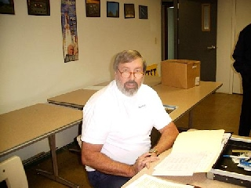

CLUB OF THE MONTH: CAVE CITY ARC
BY LARRY BRUMETT KN4IV
The Mammoth Cave Amateur Radio was formed in 1957 , the first club meetings were held at the old Dutch Mill restaurant that was located on South Green St. in Glasgow, Ky (now an empty lot just below Wyatt Oil Company) with founding members Harold (Doc) Cady W4WZH, Ellis Rice K4ESD, Emory White W4WQD, Bill Huffman K4MIQ, Ralph Huffman K4MJY, Chester Ward K4VTR.
Figure 1 President Larry Brumett KN4IV
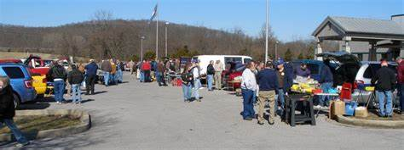
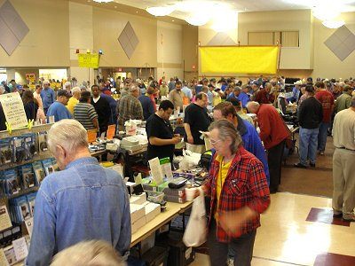
The first MCARC hamfests were actually tailgating events held in Mammoth Cave National Park close to where the motel is now and was called the Mammoth Cave Hamfest. The hamfests were family events with potluck dinners for the entire family and fun and games for the kids. Since there were few or no hamradio vendors to speak of everyone brought their own surplus equipment to sell, trade or just to show off their latest invention or build.
In the early 70’s the hamfest moved to indoor locations in an effort to generate funds to maintain the 34/94 repeater. At that time the fest was still known as the Mammoth Cave Hamfest. Over the years a variety of locations were used for the fest such as the Farmers RECC building (S. Broadway), and Effies Antiques, (near Haywood on Gorby Rd) and on occasion a High School Gym, or a Church Fellowship Hall etc. In the late 70’s early 80’s the hamfest moved to the Cave City Convention Center shortly after it’s completion. The hams on the Ky Phone Net referred to it as being the Cave City Fest and after years of hams getting confused between the Mammoth Cave Hamfest and the Cave City Hamfest the club decide in the early 90's to call it the Cave City Hamfest .
MC ARC assembled its first repeater in the early 70’s and used the familiar 34/94 pair with the callsign of W4WZH/R that belonged to Doc Cady one of the founding members and Trustee of the repeater. In the days of crystal-controlled radios, these pairs were identified by the last portion of the transmit (Input) frequency followed by the last portion of the receive (Output) frequency that the ham would put into the radio. Thus "three-four nine-four" (34/94) meant that hams would transmit on 146.34 MHz and listen on 146.94. At that time 34/94 was the most common pair of repeater frequencies and was said that you could travel the entire county almost coast to coast and never change frequencies.
Figure 2 Cave City Hamfest
The club meets the third Tuesday of each month in the clubroom (allocated by the city) located in the basement of city hall where the club maintains 2 meter, 440 and HF radios used for emergency communications when needed. The Club operates SET, Field Day and a number of Special Events during the year. Larry KN4IV

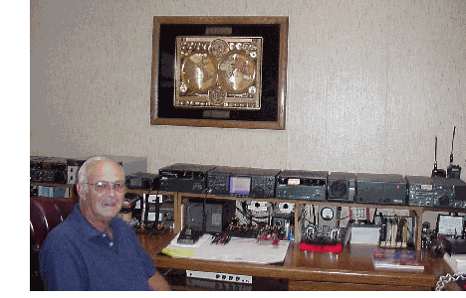
SILENT KEY
JOE MILLER K4DZM PASSED FEB. 7, 2018; Joe was also SCM in KY, ASST Director, ORS.
MEMBER SPOTLIGHT - K4DZM: Profile of K4DZM, written by Joe for the Sept. 25, 2000 KYN Newsletter:
K4DZM first licensed as KN4DZM in 1955 (that was 45 years ago) took the novice test when I was 14, and when ticket came I was 15... I have over 125 awards and certificates from operation over the years, and mostly I have been very active on all bands and most modes. Now my operating is approx. 95% CW and the other 5% on Phone on 75 meters, I only operate phone on 75. Served as SCM for the KY section back in 1979-80 for a two year term, and have been an assistant director of the Great Lakes Division for 25 years.
My history on the CW nets goes back to 1962 when I was NCS on KYN and also NCS on 9RN and on CAN, I was also a member of the TCC corps with a schedule with the PAN TCC twice a week. This was during the Vietnam War and the radiograms we passed back then were very important to our people in that country. Guess I was very active on the CW nets until 1982, that is when I was put on 2nd shift, which took me out of everything except early morning phone on 75 and DX. Came back to the day shift about 5 or 6 years ago and started showing up on some of the old hangouts.
I have been retired now for 10 months (and its great!), from the G.E. Appliances. When I retired I was the Senior Electrical Engineer in the Refrigeration Facilities Department. I worked for G.E. for 16 years and before that I worked for Anaconda Aluminum, as an Electrician and before that as Maintenance Electrician for Durkee Famous Foods div. of SCM Corp.
Started in 1968 traveling on vacations by driving to Alaska (road was all gravel back then), and the traveling bug has never left, I have been in almost all the 50 states, most of Mexico, all of Canada. In the past 12 years we have been to just about every Island in the Caribbean and some parts of South America and Central America. This past summer we visited the Dominican Republic ten years after we visited Haiti, so now we have been all over the island of Hispaniola. In September we are leaving for New Zealand and Australia, I will be in Sydney about one week after the 2000 Olympics has finished. We will be traveling to every Region of Australia even out to Perth in western part of the continent.
What’s next? Probably China next year for the big trip and the year after to Africa. (Editor, Joe and Carol were about to get on the plane to China on Sept. 11, 2001. Of course their plans were changed, and I don't think they ever made it) Our plans are to travel as long as health lets us to try and see everything that we can on Earth. Each year we plan on one large trip and 2 or 3 small trips such as a cruise or tour of Ireland, things like that... Also still work lots of DX, and plan on visiting Ham friends everywhere I go...
Now for the brag tape of the equipment that is in the picture. Starting from the right of the PIX:
An Icom R-70 receiver with two HT's behind it, both dual banders an Icom Z1A and a Standard C500, Pwr supply and then Icom SP-21 speaker then the IC-2KL Amplifier then the Icom IC-756 Transceiver with the screen. Next to that is the AT-500 automatic antenna tuner, then the little Icom 706MKII. Behind my head is the Ten-Tec Hercules II Amp. that I use with the 706. To the left then is an Icom 701 and Pwr supply, and out of sight is a Heathkit HA-14Amp. For the 701 station, and another AT-500 used with the 706 station.
Out of sight to the right is where the 2 Meter junk is located, a Kenwood TR-7400A and a KLM 140 watt amplifier, and then the Ten-Tec Mode B Satellite station with the Mirage 100 watt amp. For 440. In the drawer beneath the desktop is my CW keyboard and a set of paddles. On top of the desk is 4 different sets of home made paddles of my design and behind me on the desk is another 6 sets of paddles (I have lots more in display case) along with lots of bugs and collector keys.
The rest of the shack is just Computers, to the Right is my old 486 terminal and TV connected to the local cable. To the left of the operating position is the secondary position and an old TRS-80 (my original computer from the 70's) that I still use for RTTY. Then down the left wall is a HP plotter and another computer desk with a 386 notebook then a HP Deskjet-1000 color printer. Then another computer desk which is behind the main op position where I usually hang out at when using the terminals... on this desk I have my Pentium 3 notebook and a 500 Mhz Dell main terminal. All the computers have either 17" monitors or are using the 15" flat digital screens.
As you can see this is more like a RTTY brag tape but that is just the main stuff. Sitting on the floor is a Drake R4 receiver and a TenTec SP-325 Rx and more stuff, I think after doing this I will sell about 2/3 of all the equipment and will still have a lot... P.S. in the garage I have 2 386 terminals and four PLC's that I have programmed to run some programs...
Haven't even got to the outside yet... so will make it quick. A dipole Inverted V for 80 meters. A TA-36 six element tribander and a Hygain High Tower (full size vertical for 80 through 10) looks like a tower but is a 57' tall vertical antenna with 2000 sq. ft. of radials. On 2 and 440 I have two systems one 12 element 2 meter yagi at 50' and my Satellite antenna system 2 & 440 on top of a 24' tower for azimuth and elevation rotations. Do you want to buy any ham radio junk? This is just too much! Take care and see ya later.
Joe Miller K4DZM
Published September 25, 2000.
Teddy R. Mullins, WB4ELR Lexington KY
Passed away January 11, 2018. He loved amateur radio both as an operator on the HF bands and local repeaters, and he loved to tinker with building kits. He built his first transmitter/receiver from a HeathKit project kit, got on the air and never looked back. He was well known from his participation on nets throughout Kentucky, and from his association with the Bluegrass ARS in Lexington. He was well respected by all who knew him and will be missed.
Gerald Wyatt K4UNW Paducah,KY
Passed away Dec. 20th, 2017.

APPROACHING HAMFESTS
MARCH 3RD : CAVE CITY HAMFEST:
APRIL 7: ETOWN HAMFEST
APRIL 28: ASHLAND KY HAMFEST

ARES AND NTS REPORTS – JANUARY 2018

SEE LINK AT WWW.ARRL.ORG KY SECTION

